Scientific Experimentation and Evaluation
Arka Mallick, Daiem Ali,Chun Kwang Tan
Hochschule Bonn-Rhien-Sieg
11.05.2015
Design of robot
The design of the robot is modified from the previous assignment such that we are able to mount the marker on top of the robot. This because the AICISS optical tracking system relies on ceiling-mounted cameras.
Below are pictures depicting how we attached the marker onto the robot.
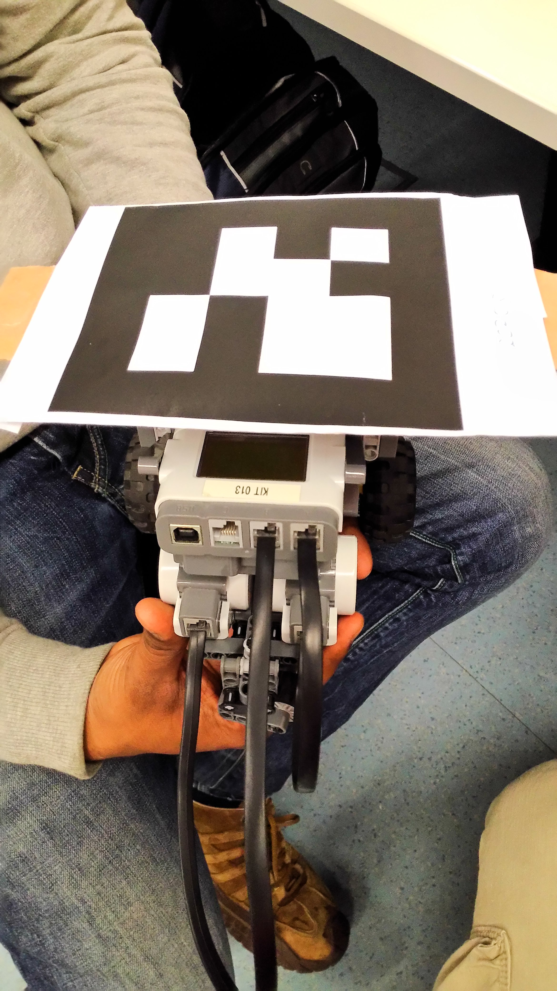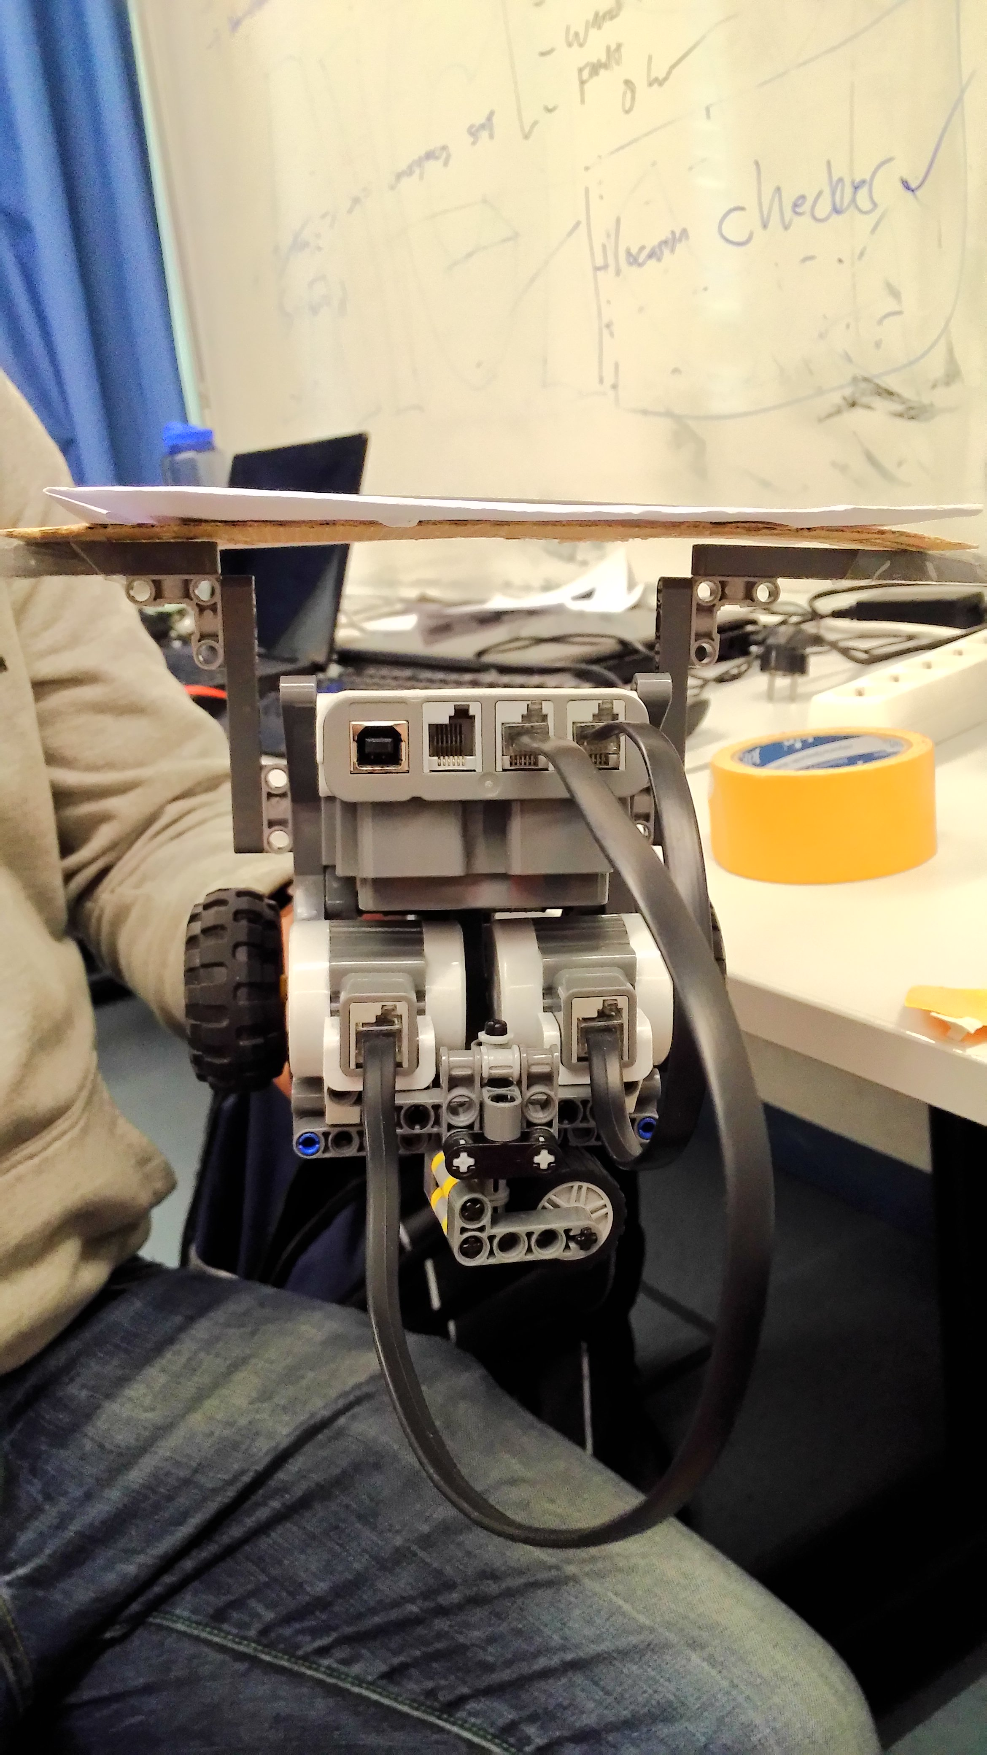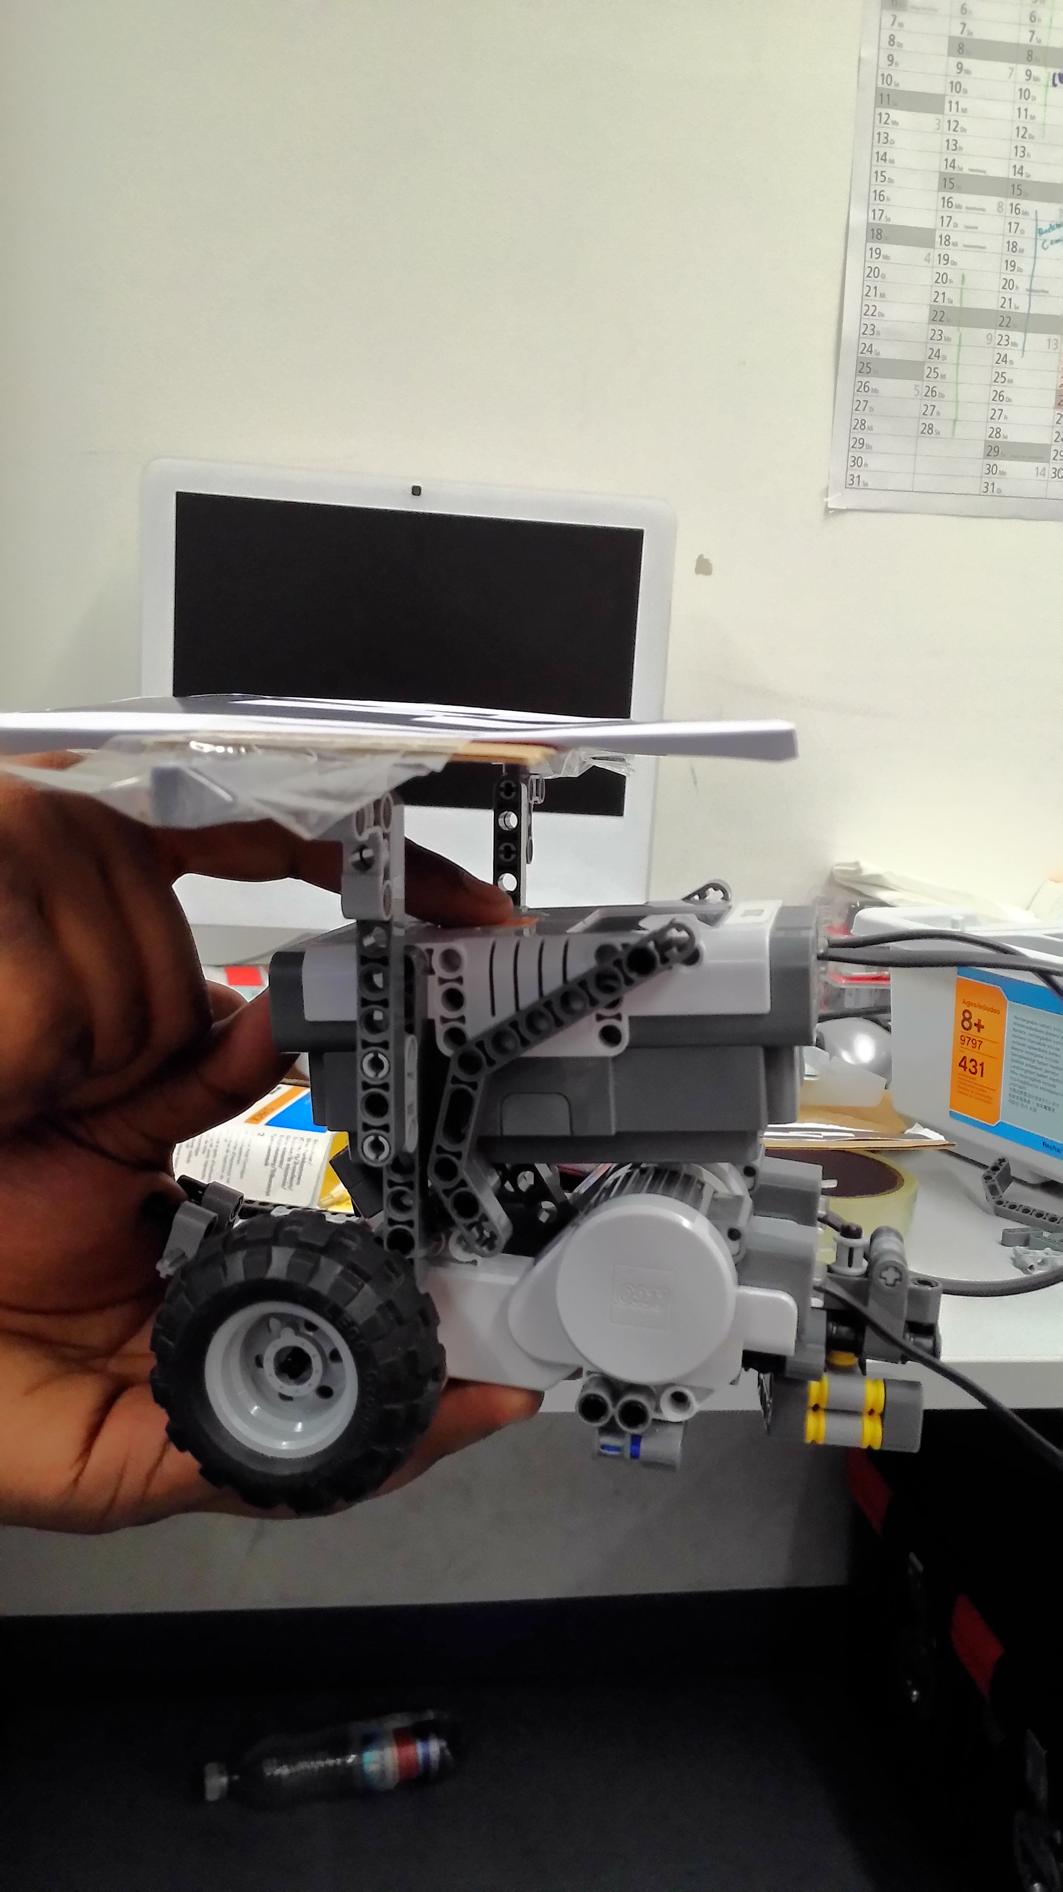
Fig 1, 2, 3 (Views from Front-top, back and side)
The marker is attached in a way that the center of the marker corresponds approximately to a point between the two drive wheels (Fig 3 View from side)
AICISS Optical Tracking System
To retrieve the pose of the center of motion of the robot, we started up the AICISS tracking system, which reads the position of the marker and returns its coordinates.
<<Add in specifically how it does that>>
Estimation of pose measurement error
To estimate the pose measurement error, we ran the experiment for 21 times and obtained readings.
- For each of the 21 trials, we obtained 50 readings of the robot when it is unmoving
- We then calculated the mean and standard deviation for each trial and finally for all trials. Results are summarised below. <<To be added at a later time>>

